PHONEBOOK APPLICATION

NAME: M. ASHWIN ANTONY

REG NO: RA2111002010028

DEPARTMENT: MECHANICAL ENGINEERING

SUBMITTED TO:

DR. R. RAJKUMAR

DSBS

SCHOOL OF COMPUTING

SRMIST

JANUARY 2022

ABSRACT:

This mini project allows us to perform simple operations like in our mobile phone. We can add, list, modify and remove phonebook records. File handling and data structure concepts has been used in this project.

The source code in this project is simple to understand. Personal information such as name, gender, father’s name, phone number and email address are asked while adding a record into the Phonebook. These records can then be modified, listed, searched for and removed.

I have used many functions in this mini project. These functions are easy to understand as their name only signifies their respective operations. Adding new records, listing them, modifying them and updating, search for contacts saved, and deleting the phonebook records are the basic functions which make up the main menu of this Phonebook application.

FLOW CHART:

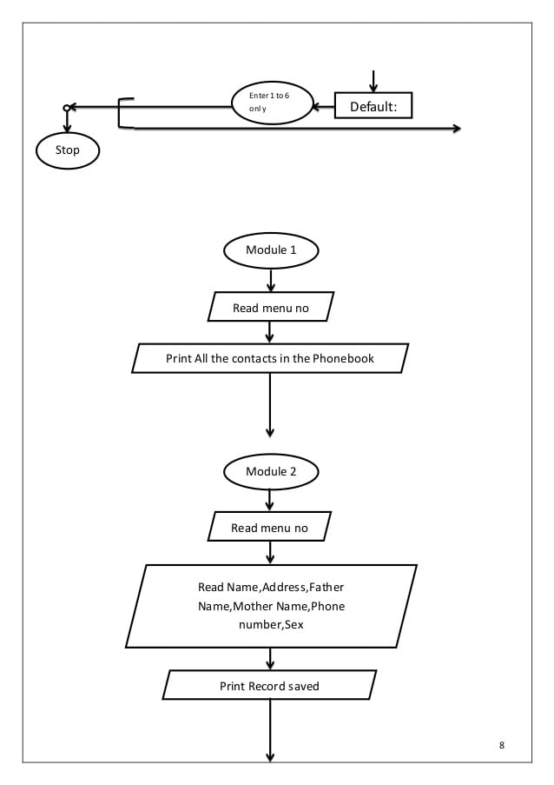

PROGRAM :

#include<stdio.h>

#include<conio.h>

#include<string.h>

#include<stdlib.h>

#include<windows.h>

struct person

{

char name[35];

char address[50];

char father_name[35];

char mother_name[30];

long int mble_no;

char sex[8];

char mail[100];

char citision_no[20];

};

void menu();

void got();

void start();

void back();

void addrecord();

void listrecord();

void modifyrecord();

void deleterecord();

void searchrecord();

int main()

{

system("color 5f");

start();

return 0;

}

void back()

{

start();

}

void start()

{

menu();

}

void menu()

{

system("cls");

printf("\t\t**********WELCOME TO PHONEBOOK*************");

printf("\n\n\t\t\t MENU\t\t\n\n");

printf("\t1.Add New \t2.List \t3.Exit \n\t4.Modify \t5.Search\t6.Delete");

switch(getch())

{

case '1':

addrecord();

break;

case '2': listrecord();

break;

case '3': exit(0);

break;

case '4': modifyrecord();

break;

case '5': searchrecord();

break;

case '6': deleterecord();

break;

default:

system("cls");

printf("\nEnter 1 to 6 only");

printf("\n Enter any key");

getch();

menu();

}

}

void addrecord()

{

system("cls");

FILE *f;

struct person p;

f=fopen("project","ab+");

printf("\n Enter name: ");

got(p.name);

printf("\nEnter the address: ");

got(p.address);

printf("\nEnter father name: ");

got(p.father_name);

printf("\nEnter mother name: ");

got(p.mother_name);

printf("\nEnter phone no.:");

scanf("%ld",&p.mble_no);

printf("Enter sex:");

got(p.sex);

printf("\nEnter e-mail:");

got(p.mail);

printf("\nEnter citizen no:");

got(p.citision_no);

fwrite(&p,sizeof(p),1,f);

fflush(stdin);

printf("\nrecord saved");

fclose(f);

printf("\n\nEnter any key");

getch();

system("cls");

menu();

}

void listrecord()

{

struct person p;

FILE *f;

f=fopen("project","rb");

if(f==NULL)

{

printf("\nfile opening error in listing :");

exit(1);

}

while(fread(&p,sizeof(p),1,f)==1)

{

printf("\n\n\n YOUR RECORD IS\n\n ");

printf("\nName=%s\nAdress=%s\nFather name=%s\nMother name=%s\nMobile no=%ld\nSex=%s\nE-mail=%s\nCitizen no=%s",p.name,p.address,p.father_name,p.mother_name,p.mble_no,p.sex,p.mail,p.citision_no);

getch();

system("cls");

}

fclose(f);

printf("\n Enter any key");

getch();

system("cls");

menu();

}

void searchrecord()

{

struct person p;

FILE *f;

char name[100];

f=fopen("project","rb");

if(f==NULL)

{

printf("\n error in opening\a\a\a\a");

exit(1);

}

printf("\nEnter name of person to search\n");

got(name);

while(fread(&p,sizeof(p),1,f)==1)

{

if(strcmp(p.name,name)==0)

{

printf("\n\tDetail Information About %s",name);

printf("\nName:%s\naddress:%s\nFather name:%s\nMother name:%s\nMobile no:%ld\nsex:%s\nE-mail:%s\nCitision no:%s",p.name,p.address,p.father_name,p.mother_name,p.mble_no,p.sex,p.mail,p.citision_no);

}

else

printf("file not found");

}

fclose(f);

printf("\n Enter any key");

getch();

system("cls");

menu();

}

void deleterecord()

{

struct person p;

FILE *f,*ft;

int flag;

char name[100];

f=fopen("project","rb");

if(f==NULL)

{

printf("CONTACT'S DATA NOT ADDED YET.");

}

else

{

ft=fopen("temp","wb+");

if(ft==NULL)

printf("file opaning error");

else

{

printf("Enter CONTACT'S NAME:");

got(name);

fflush(stdin);

while(fread(&p,sizeof(p),1,f)==1)

{

if(strcmp(p.name,name)!=0)

fwrite(&p,sizeof(p),1,ft);

if(strcmp(p.name,name)==0)

flag=1;

}

fclose(f);

fclose(ft);

if(flag!=1)

{

printf("NO CONACT'S RECORD TO DELETE.");

remove("temp.txt");

}

else

{

remove("project");

rename("temp.txt","project");

printf("RECORD DELETED SUCCESSFULLY.");

}

}

}

printf("\n Enter any key");

getch();

system("cls");

menu();

}

void modifyrecord()

{

int c;

FILE *f;

int flag=0;

struct person p,s;

char name[50];

f=fopen("project","rb+");

if(f==NULL)

{

printf("CONTACT'S DATA NOT ADDED YET.");

exit(1);

}

else

{

system("cls");

printf("\nEnter CONTACT'S NAME TO MODIFY:\n");

got(name);

while(fread(&p,sizeof(p),1,f)==1)

{

if(strcmp(name,p.name)==0)

{

printf("\n Enter name:");

got(s.name);

printf("\nEnter the address:");

got(s.address);

printf("\nEnter father name:");

got(s.father_name);

printf("\nEnter mother name:");

got(s.mother_name);

printf("\nEnter phone no:");

scanf("%ld",&s.mble_no);

printf("\nEnter sex:");

got(s.sex);

printf("\nEnter e-mail:");

got(s.mail);

printf("\nEnter citizen no\n");

got(s.citision_no);

fseek(f,-sizeof(p),SEEK_CUR);

fwrite(&s,sizeof(p),1,f);

flag=1;

break;

}

fflush(stdin);

}

if(flag==1)

{

printf("\n your data id modified");

}

else

{

printf(" \n data is not found");

}

fclose(f);

}

printf("\n Enter any key");

getch();

system("cls");

menu();

}

void got(char *name)

{

int i=0,j;

char c,ch;

do

{

c=getch();

if(c!=8&&c!=13)

{

*(name+i)=c;

putch(c);

i++;

}

if(c==8)

{

if(i>0)

{

i--;

}

// printf("h");

system("cls");

for(j=0;j<i;j++)

{

ch=*(name+j);

putch(ch);

}

}

}while(c!=13);

*(name+i)='\0';

}

RESULTS:

<TEXT>

SCREENSHOTS:

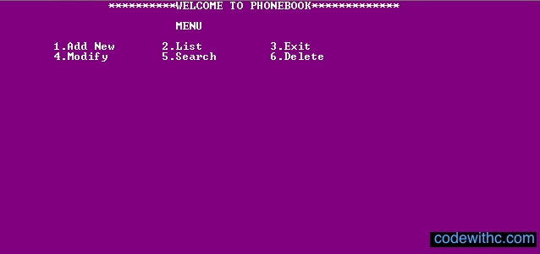

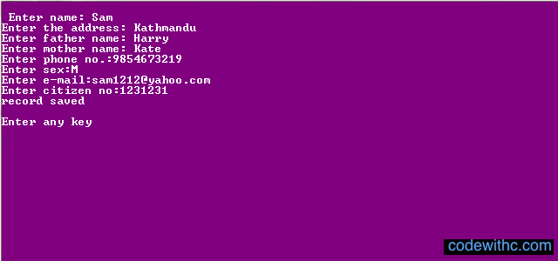

DECLARATION:

I hereby declare that this project titled phonebook application is submitted by me to SRMIST carried out under the guidance of MR. DR. R. Rajkumar and thankful for the opportunity.

RERERENCES:

GOOGLE.COM